Application to become a European Blue School
Dear teacher,
Welcome to the application process to turn your school into a European Blue School.
Please provide us below the detailed information on the project developed and conducted by your students. Your application will be reviewed by the coordinating team of the Network of European Blue Schools and you will be further contacted.
In case you experience any troubles or if you have any doubts on the process please write to info@blueschools.eu.
Please read the handbook on the Network of European Blue School to gain more insights on how to become a European Blue School.
Certification
Are you already certified with a partner program (e.g. Plastic Pirates, Escola Azul) or received funding from a partner project – ProBleu, SHORE, BlueLights)
▢ Yes
▢ No

Teacher
First name of applicant teacher
Last name of applicant teacher
E-Mail of applicant teacher

School
Name of school
Website URL of school
Country
City

GPS coordinates of the city
Participating EU Blue Schools will be featured in an interactive map. We kindly ask you to provide the coordinates for the city in which your school is based in. You can use online tools to find your coordinates, i.e. www.latlong.net
Latitude (Correct format: i.e. 52.520008)
Longitude (Correct format: i.e. 13.404954)
Sea basin (Select)
- Atlantic Ocean
- Baltic sea
- Black Sea
- Mediterranean Sea
- North Sea

Region (select)
- Both
- Coastal (<20km from the sea)
- Inland (>20km from the sea)

Project
Name of the project (English)
Name of the project (native language)
URL of the project (if applicable)
Summary of the project
Please tell us how your students are are finding their blue link to the ocean. Consider the following points to structure your response:
- Objectives: Clearly state the specific goals of the project.
- Activities: Describe what the students worked on or are currently working on.
- Approach: Explain the methodologies or strategies employed in the project.
Provide specific examples of activities, including what the students explored, analyzed, organized, constructed, or participated in and the methods they used. Avoid vague descriptions like "students enjoyed the project" or "developed new skills." Instead, provide concrete instances of their engagement and learning outcomes.
(max 300 words)
Starting date of the project (Please be aware that only completed or ongoing projects are eligible for certification. If your project is still in the planning stage, consider applying during the semester when the project is actively underway.)

End date of the project
Is the project linked to school curricula ?
▢ Yes
▢ No

If yes, to which subjects is it connected to ?

Are other classes, teachers and schools involved ?
Classes
▢ Yes
▢ No
Teachers
▢ Yes
▢ No
Schools
▢ Yes
▢ No
School year
- Select all
- 2020-2021
- 2021-2022
- 2022-2023
- 2023-2024
- 2024-2025

School level (select)
- Junior high school
- Kindergarten
- Middle school
- Primary school
- Secondary school
- Senior high school
- Technical school
- Vocational school

How many students are involved ?
In which major category does the project fall into ?
- Biodiversity
- Biotechnology
- Food from the ocean
- Healthy ocean
- Maritime culture
- Ocean and climate
- Other

Is the project being developed in any other kind of school programme/certification? If so, please specify:
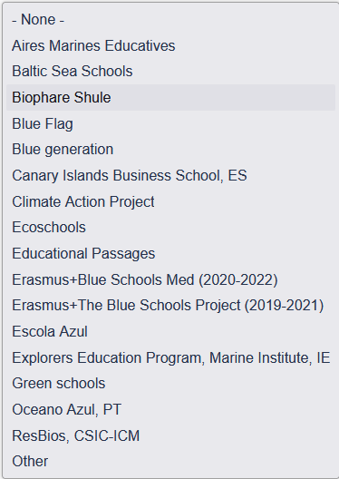

Compliance with the Network of European Blue School criteria

Mandatory criteria
▢ Develop a project with interlinked activities
A project consists of several complementary activities under the umbrella of one central topic, e.g. the students learn about the ocean, perform activities in the field, do art or lab activities present their work.

▢ Produce a clear output
The initiative encourages students to be active learners and develop a product, object, event or service that can be exhibited or used as a tool for communication.

▢ Involve all students
Students play an active role in all phases of the project. Not all student in from school have to be involved in the project, but each student involved in it has to actively partake in the project activities.

▢ Collaborate with a local partner
Collaborative work is key to success. Invite an expert, marine scientist, NGO, science centre, maritime company and/or government body to help facilitate the creation, implementation, and communication of the project. Go to the EU4Ocean Platform members to find a partner!
Identify the partners involved in the project
Identify the partners involved in the project. Please list the FULL NAMES of all partners involved in the project, avoiding acronyms or vague terms like "municipality" or "NGO". Include the website URLs of the partners, if available.

▢ Communicate to the community
Let students improve their communication skills and feel more engaged with thier local community by taking about the project in a meaningful and informed way, starting with their own social environment, e.g.

Identify the communication actions of the project
Please specify the communication actions of the project. Avoid general terms like "a play" or "social media campaign." For online activities such as articles, social media campaigns, or YouTube videos, provide direct links. For physical activities, provide a link to pictures stored on Google Drive or similar platforms. The pictures will be used for project evaluation purposes only and will not be published.

Optional criteria
▢ Provide authentic learning experiences
Provide the students with opportunies to find the Blue both in the classroom and in real-life settings. This initiative allows pupils to apply what they learned in class in hands-on projects with real-life relevance and impact.

▢ Work multidisciplinary
Explore your topic through many school subjects, allowing access for students with different strengths, viewpoints, and interests. Multi-disciplinary projects provide learning opportunities beyond science. You can incorporate aspects of e.g. languages, history, (water) sport, art, or economy.

▢ Mobilise beyond the classroom
This initiative allows you to move beyond your classroom by offering opportunities for collaboration among teachers of different disciplines, diverse age groups, and numerous subjects. The project creates an opportunity to work as a school, and not just a class.

▢ Foster a land-sea interaction
Schools from coastal areas are invited to collaborate with inland schools to exchange experiences and information on the differances and similarities they observe in their environments, econommies, or culture. Cooperation is facilitated via eTwinning.

▢ Bring in a European dimension
This initiative facilititates cultural exchange amongst European schools, allowing students to see themselves and thier work in a European context and collaborate with peers from across the Union. The initiative offers the opportunity to connect with different partner schools via eTwinning, travel abroad via a funded exchange programme, or develop more permanent collaborations.

Contact
If you would like to provide your contact details to other schools, please enter them here. Please be aware that this information will be shown on your public project page. We suggest you to enter the email address with "at" instead of "@" to avoid spam (i.e. "info at school.eu").

